A. Rates of reaction: Practical methods and calculating rates of reaction
- A student carried out a reaction between calcium carbonate solid (CaCO₃) and hydrochloric acid (HCl) producing dissolved calcium chloride (CaCl₂), carbon dioxide and water. Write the balanced symbol equation for this reaction, including state symbols. (3)
CaCO₃ (s) + 2HCl (aq) CaCl₂ (aq) + CO₂ (g) + H₂O (l)
All formulae correct [1]
Balancing correct (dependent upon first mark) [1]
All state symbols correct [1]
- Below is a table of results for the reaction. The student measured the volume of gas released every ten seconds.
Time in seconds | Volume of carbon dioxide released in cm³
0 | 0
10 | 8
20 | 16
30 | 22
40 | 24
50 | 25
60 | 26
70 | 26
Calculate the rate of the reaction in the first ten seconds. Give the unit. (3)
8/10 [1] OR 0.8 [2] cm³ [1]
- What is the rate of the reaction between 30 and 40 seconds? (2)
2/10 [1]
BUT 0.2 [2]
- Is the rate of reaction faster, slower or the same between 0 and 10 seconds than between 30 and 40 seconds? Explain your answer. (2)
faster [1]
Any indication that there are more reacting particles/ORA [1]

B. Rates of reaction: Collision theory; effects of temperature, concentration, surface area and pressure on rates of reaction
- Extended response question:
The student repeated the experiment, this time however he used 2.0 Molar acid rather than 1.0 Molar acid. Describe or draw a labelled diagram to show how the student might carry out the experiment, calculate the rate of reaction that the student might calculate for this new reaction for the first ten seconds and what volume of carbon dioxide would you expect him to collect at the end of the experiment. (6)
Here are his original results:
Time in seconds | Volume of carbon dioxide released in cm³
0 | 0
10 | 8
20 | 16
30 | 22
40 | 24
50 | 25
60 | 26
70 | 26
Method
Container e.g. conical flask containing calcium carbonate and hydrochloric acid [1]
Method of transferring gas produced to vessel for measuring volume e.g. delivery tube [1]
Labelled vessel for measuring volume e.g. gas syringe/upturned measuring cylinder [1]
Rate of reaction
16/10 [1] OR 1.6 [2]
New volume of carbon dioxide
52 (cm³) [1]

- Give two other ways that the student might decrease the rate of reaction, other than changing the concentration. (2)
Any two from decrease temperature/decrease surface area/remove a catalyst [2]
- What two requirements must be met for reacting particles to react? (2)

They must collide, [1] with sufficient energy [1]

- What is the activation energy of a reaction? (2)

The minimum amount of energy [1] particles must have in order to react [1]

- For the reaction below, explain what would happen to the rate of the reaction and why if the solid magnesium was cut into smaller pieces. (4)

Hydrochloric acid + magnesium magnesium chloride + hydrogen

Rate of reaction would increase [1] surface area of magnesium has increased [1] frequency of collisions increases [1] larger surface area to volume ratio [1]

- A student calculated that the surface area had been increased to three times its original size. Describe and explain what you think would happen to the rate of reaction. (2)

The rate of reaction would increase by three [1] as the frequency of collisions would increase by three [1]
C. Rates of reaction: Catalysts
- What is the name given to catalysts in biological systems? (1)

Enzymes (1)

- How do catalysts increase the rate of a chemical reaction? (2)

They provide a different/ alternative pathway for the reaction (1)
That has a lower activation energy (1)

- For the energy profile below decide which reaction(s) are catalysed, which reaction was the original reaction without a catalyst and which is the best catalyst to use for the reaction. Explain your decisions. (4)

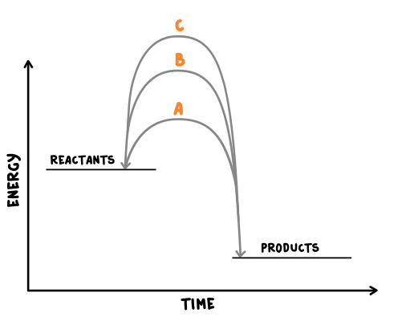

C is the uncatalysed reaction [1] as it has the highest activation energy [1]
A is the best catalyst to use [1] as it lowers the activation energy the most [1]

D. Energy changes: Exothermic and endothermic reactions
- What is an exothermic reaction? (2)

One that transfers energy to the surroundings [1]

The temperature of the surroundings increases [1]
- Give two examples of exothermic reactions. (2)
Any two from combustion/oxidation/neutralisation (accept examples e.g. hydrochloric acid and sodium hydroxide) [2]
- What is an endothermic reaction? (2)

One that takes in energy from the surroundings [1]

The temperature of the surroundings decreases [1]
- Give one example of an endothermic reaction. (1)
Any one from thermal decompositions/sports injury packs (accept examples e.g. citric acid and sodium hydrogen carbonate) [1]

- Extended response question:
A student wishes to investigate which of three metals will give the largest exothermic reaction when they react with hydrochloric acid. Describe how she would carry out the experiment making sure it was a fair test. (6)
- Level 3 (5-6 marks)

Complete description of experiment and fair test
- Level 2 (3-4 marks)

Partial description of experiment and fair test
- Level 1 (1-2 marks)
Limited description of experiment and fair test

The reaction will be exothermic therefore the rise in temperature will be measured [1] the greatest rise in temperature signifies the most exothermic [1]

Mass of metal/surface area must be the same [1]

Temperature of acid must be the same [1]

Concentration of acid must be the same [1]

Mention of agitation or stirring [1]

E. Energy changes: Overall heat energy change for a reaction and calculating energy change
- (HT only) Below is a balanced chemical reaction between nitrogen gas and oxygen gas to produce nitrogen monoxide. The bond energy between two nitrogen atoms is 942kJ/mol, between two oxygen atoms is 494 Kj/mol and between a nitrogen atom and an oxygen atom is 607kJ/mol.
Calculate the overall energy change for this reaction. (4)
N₂ + O₂ → 2NO

Bond energies for the reactants 1,436 kJ/mol [1]

Bond energies for the products 1,214 kJ/mol [1]

Answer = + [1] 222kJ/mol [1]

- (HT only) Draw a reaction profile for the above reaction. (4)

Correctly labelled axes [1] energy of products above reactants [1] both reactants and products labelled on correct lines [1] curved line showing activation energy [1]

- Describe the energy release in an exothermic reaction in terms of bond energies. (2)

Energy released from forming bonds is greater [1] than energy needed to break bonds [1]

F. Activation energy and reaction profiles
- What is activation energy? (1)

The energy needed for a reaction to occur [1]

- Extended response question:
The following reaction is exothermic:
H₂ (g) + F₂ (g) → 2HF (g)
Draw a reaction profile to show this reaction, including the relative energies of the reactants and products, the activation energy and the overall energy change. (6)
